AI ASSISTED CODING
Week 5.4 Assignment
NAME:T.TEJASRI
HT NO:2303A51557
BATCH:09

TASK-01:
#Generate a Python program that collects user details such as name, age, and email.Provide text input boxes for name and age, and an email input box for email.
import tkinter as tk
from tkinter import messagebox
def submit_details():
name = name_entry.get()
age = age_entry.get()
email = email_entry.get()

if not name or not age or not email:
messagebox.showwarning("Input Error", "Please fill in all fields.")
return

try:
age = int(age)
except ValueError:
messagebox.showwarning("Input Error", "Age must be a number.")
return

messagebox.showinfo("User Details", f"Name: {name}\nAge: {age}\nEmail: {email}")

# Create main window
root = tk.Tk()
root.title("User Details Form")

# Labels and Entry Boxes
tk.Label(root, text="Name:").grid(row=0, column=0, padx=10, pady=5)
name_entry = tk.Entry(root)
name_entry.grid(row=0, column=1, padx=10, pady=5)

tk.Label(root, text="Age:").grid(row=1, column=0, padx=10, pady=5)
age_entry = tk.Entry(root)
age_entry.grid(row=1, column=1, padx=10, pady=5)

tk.Label(root, text="Email:").grid(row=2, column=0, padx=10, pady=5)
email_entry = tk.Entry(root)
email_entry.grid(row=2, column=1, padx=10, pady=5)

# Submit Button
submit_button = tk.Button(root, text="Submit", command=submit_details)
submit_button.grid(row=3, columnspan=2, pady=10)

root.mainloop()

# Data Protection Guidelines:
# 1. Do not store sensitive data unnecessarily.
# 2. Encrypt data if storage is required.
# 3. Restrict access to authorized users.
# 4. Update software regularly.

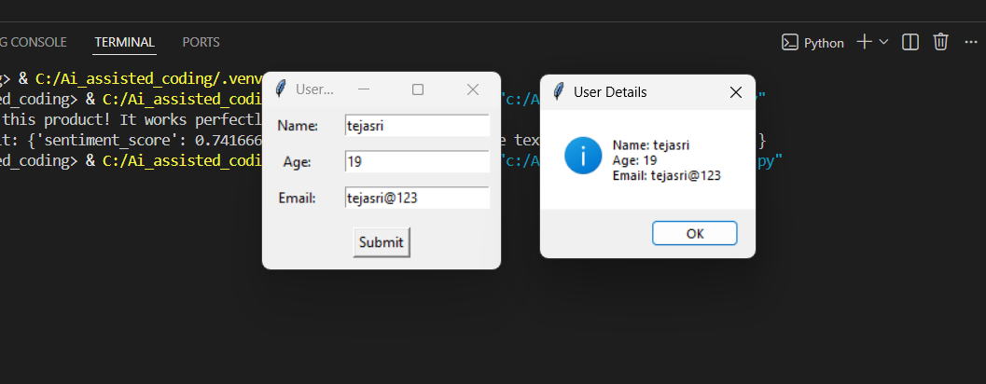
EXPLANATION:
Creates a graphical form using Tkinter.
Takes Name, Age, and Email from the user.
Validates input (no empty fields, age must be number).
Displays entered data using a popup box.

#TASK-02
# generate a Python function for sentiment analysis and to identify and handle potential biases in the data
# This script performs sentiment analysis on text data and includes comments on identifying and handling potential biases.
from textblob import TextBlob
def analyze_sentiment(text):
# Perform sentiment analysis using TextBlob
blob = TextBlob(text)
sentiment = blob.sentiment.polarity
# Identify potential biases in the text
# Check for overly positive or negative language
if sentiment > 0.5:
bias_note = "The text may be overly positive."
elif sentiment < -0.5:
bias_note = "The text may be overly negative."
else:
bias_note = "The text appears to be neutral."

# Handle biases by providing context
return {
'sentiment_score': sentiment,
'bias_note': bias_note
}
# Direct input text (no user input)
sample_text = "I absolutely love this product! It works perfectly and is amazing."
# Analyze sentiment
result = analyze_sentiment(sample_text)
# Display result
print("Text:", sample_text)
print("Sentiment Analysis Result:", result)

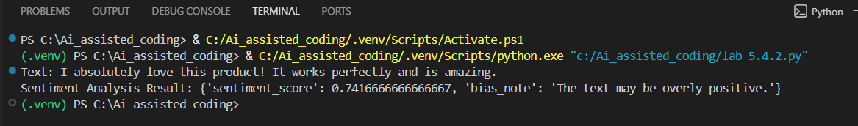
EXPLANATION:
Uses TextBlob to analyze text sentiment.
Finds whether text is:
- Positive
- Negative
- Neutral
Detects possible bias in the text.

#TASK-03
#Generate a Python program that recommends products based on user history. Ask it to follow ethical guidelines like transparency and fairness.
# This script recommends products based on user history while adhering to ethical guidelines such as transparency and fairness.
# Generate that include explanations, fairness checks

import random
# Sample product database
products = {
'Electronics': ['Smartphone', 'Laptop', 'Headphones', 'Smartwatch'],
'Books': ['Fiction Novel', 'Science Textbook', 'Biography', 'Self-help Book'],
'Clothing': ['T-shirt', 'Jeans', 'Jacket', 'Sneakers']
}
def recommend_products(user_history):
# Analyze user history to determine preferences
preferred_categories = {}
for item in user_history:
for category, items in products.items():
if item in items:
if category in preferred_categories:
preferred_categories[category] += 1
else:
preferred_categories[category] = 1

# Sort categories by preference
sorted_categories = sorted(preferred_categories, key=preferred_categories.get, reverse=True)

# Recommend products from top preferred categories
recommendations = []
for category in sorted_categories:
available_products = [p for p in products[category] if p not in user_history]
recommendations.extend(random.sample(available_products, min(2, len(available_products))))
# Ensure fairness by including diverse product options
if len(recommendations) < 4:
for category, items in products.items():
if category not in sorted_categories:
available_products = [p for p in items if p not in user_history]
recommendations.extend(random.sample(available_products, min(1, len(available_products))))

# Limit recommendations to a maximum of 5 products
recommendations = recommendations[:5]

# Transparency: Explain the recommendation process
explanation = f"Recommendations are based on your previous purchases: {user_history}. We considered your preferences and ensured a diverse selection."
return {
'recommendations': recommendations,
'explanation': explanation
}
# Example user history
user_history = ['Smartphone', 'Fiction Novel', 'T-shirt']
result = recommend_products(user_history)
print("Product Recommendations:", result['recommendations'])
print("Explanation:", result['explanation'])
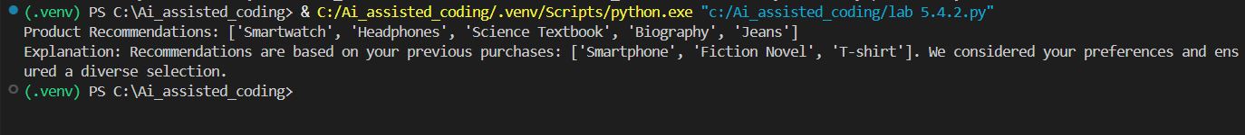
EXPLANATION:
Recommends products based on user’s previous purchases.
Uses categories like Electronics, Books, Clothing.
Ensures fairness and diversity.

#TASK-04
#Secure Logging in Web Application
import logging

def setup_logging():

logger = logging.getLogger('web_app_logger')
logger.setLevel(logging.DEBUG)

console_handler = logging.StreamHandler()
file_handler = logging.FileHandler('web_app.log')

console_handler.setLevel(logging.INFO)
file_handler.setLevel(logging.DEBUG)

formatter = logging.Formatter(
'%(asctime)s - %(levelname)s - %(message)s'
)

console_handler.setFormatter(formatter)
file_handler.setFormatter(formatter)

logger.addHandler(console_handler)
logger.addHandler(file_handler)

return logger

# Example usage
if __name__ == "__main__":

logger = setup_logging()

logger.info("Application started.")

try:
logger.debug("Processing request.")
user_password = "secret123" # Never log this
logger.debug("User logged in.")

except Exception as e:
logger.error("Error: " + str(e))

finally:
logger.info("Application stopped.")

# Logging Ethics:
# 1. Do not log passwords.
# 2. Avoid storing personal data.
# 3. Use log levels properly.
# 4. Protect log files.

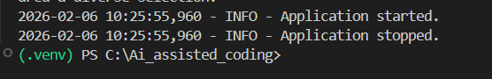
EXPLANATION:
Creates a logging system for a web app.
Stores logs in:
- Console
- File (web_app.log)
Uses different log levels.

#TASK-05
#Machine Learning Model with Responsible Documentation
from sklearn.datasets import load_iris
from sklearn.model_selection import train_test_split
from sklearn.ensemble import RandomForestClassifier
from sklearn.metrics import classification_report
import joblib

def train_model():

iris = load_iris()

X = iris.data
y = iris.target

X_train, X_test, y_train, y_test = train_test_split(
X, y, test_size=0.2, random_state=42
)

model = RandomForestClassifier(
n_estimators=100,
random_state=42
)

model.fit(X_train, y_train)

return model, X_test, y_test

def evaluate_model(model, X_test, y_test):

y_pred = model.predict(X_test)

report = classification_report(y_test, y_pred)

print("Classification Report:\n", report)

if __name__ == "__main__":

model, X_test, y_test = train_model()

evaluate_model(model, X_test, y_test)

joblib.dump(model, "rf_iris_model.pkl")

"""
README – Responsible Usage Guidelines:
1. Explainability:
Understand how predictions are made.
2. Accuracy Limits:
Works only on Iris dataset.
3. Fairness:
Check for bias regularly.
4. Transparency:
Document training process.
5. Accountability:
Monitor performance continuously.
"""
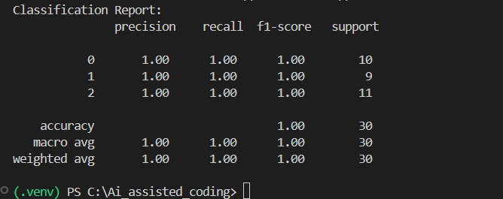
EXPLANATION:
Loads Iris dataset.
Splits data into training and testing.
Trains a Random Forest model.
Evaluates performance.
Saves model file.

